**POWER BI ASSIGNMENT-19**

Topic – Charts

Exercise – Show a chart comparing films when you click on each genre in a tree map.

Step-1. Create a tree map visual based on the table of genres

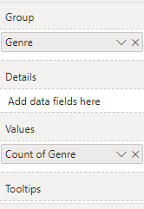

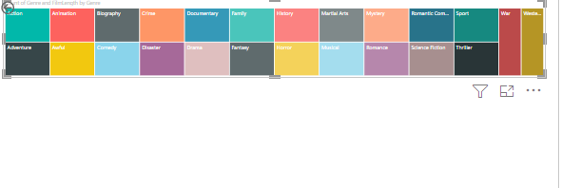

Step-2. Insert column chart showing the length of each film, and get this to be filtered when you click on genre.

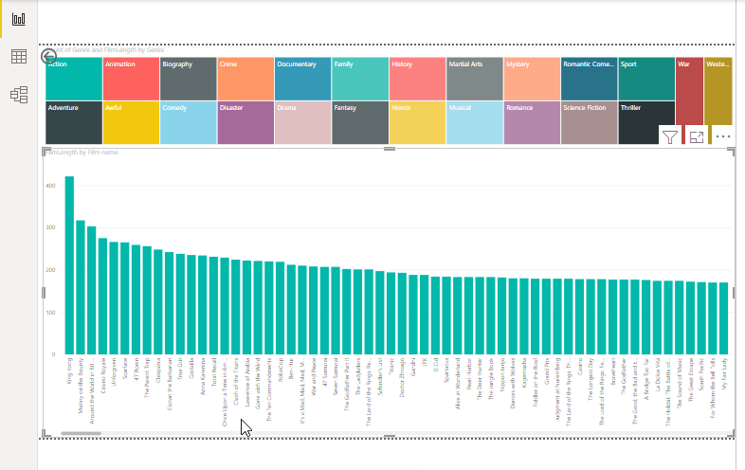

Step-3. Now when we select **sports** genre from tree map the column chart get filtered accordingly as shown below.

